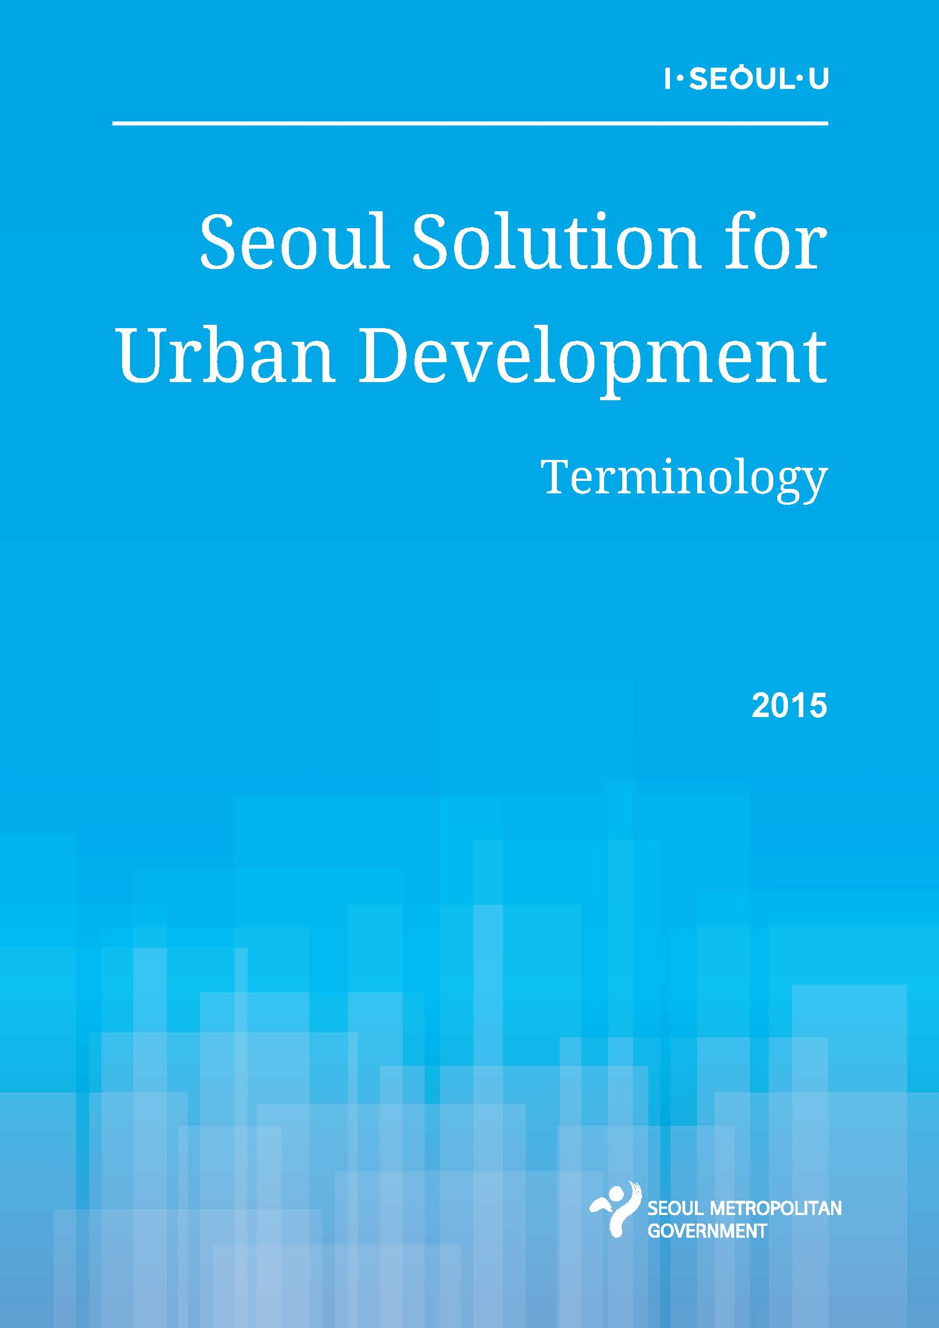

|  |  |
| --- | --- |
| ㄱ | |
| 가로수 | roadside tree |
| 개발제한구역 | limited development zone |
| 건축법 | building act |
| 건폐율 | building-to-land ratio |
| 경도 | hardness |
| 경량형 옥상녹화 | light weight roof gardening |
| 계량수단 | measuring means |
| 계획과제 | planning task |
| 계획지표 | planning Index |
| 고가도로 | elevated road |
| 고도정수처리시설 | advanced water purification facilities |
| 고도처리시설 | advanced disposal facilities |
| 고용기반 | employment basis |
| 고철 | scrap metal |
| 고체연료 | solid fuel |
| 곰팡이냄새 | moldy odor |
| 공간구조 | spatial structure |
| 공간시설 | spatial Facilities |
| 공간적 범위 | spatial Range |
| 공간적합성 | space Suitability |
| 공고수역 | public water |
| 공공공지 | public open space |
| 공공재원 | public funding |
| 공공정책 | public policies |
| 공공직업훈련시설 | public vocational training facility |
| 공공하수처리장시설 | public sewage treatment facilities |
| 공급설비 | heat supply facilities |
| 공영차고지 | public garages |
| 공원녹지 | parks and landscape |
| 공원녹지/경관기본계획 | basic plan for park green/landscape |
| 공유사회 | sharing society |
| 공청회 | public hearings |
| 공해방지법 | Environmental Pollution Prevention Act |
| 공해원인자부담원칙 | polluters pay principle |
| 과대포장 | exaggerated packaging |
| 관리운영계약 | management and operation agreement |
| 광역경제권 | metropolitan economic bloc |
| 광역급행철도 | Metropolitan Express Railway |
| 광역도시계획 | Metropolitan Urban Plan |
| 광역도시철도 | Metropolitan City Railway |
| 광역환승센터 | regional transfer center |
| 교차로 | intersection |
| 교통약자 | Mobility Handicapped |
| 교통정비중기계획 | Mid-term Transport Readjustment Plan |
| 국가환경기준 | national environment standard |
| 국민임대주택 | national public housing |
| 국제금융중심지 | International Financial Center |
| 국제업무중심지 | International Business Center |
| 국토의 계획 및 이용에 관한 법률 | National Land Planning and Utilization Act |
| 국토종합계획 | Comprehensive National Territorial Plans |
| 권역별 발전계획 | Development Plan by Region |
| 규격봉투 | standard waste bag |
| 근린공원 | neighborhood park |
| 금융감독원 | Financial Supervisory Service |
| 급수과정 | Water Supply Process |
| 급행도시철도시스템 | Raipd Urban Railway System |
| 급행열차 | express train |
| 기본골격 | framework |
| 기준연도 | base year |
| 기초현황분석 | basic status analysis |
| 기후변화 | climate change |
| 기후변화조례 | Ordinance on Climate Change |
| 긴급수송기간 | emergency transportation period |
| ㄴ | |
| 나눔 장터 | sharing market |
| 내분비계 장애물질 | endocrine disruptors |
| 내시경 카메라 | endoscopy cameras |
| 냄새경보제 | smell warning system |
| 노인정 | senior citizens community center |
| 녹색서울시민위원회 | Green Seoul Citizen Committee |
| 녹색성장기본법 | Framework Act on Green Growth |
| 농림지역 | agriculture and forestry region |
| 농약 | pesticides |

|  |  |
| --- | --- |
| ㄷ | |
| 다핵구조 | structure of multi-centers |
| 대기질 관리 | air quality management |
| 대기질 예경보제 | Air Quality Forecast and Warning System |
| 대기환경기준 | air environment standard |
| 대기환경기준 | air environment standard |
| 대생활권 | large living area |
| 대피선 | sidetrack (or evacuation track) |
| 도로교통 | Road Traffic |
| 도시가스 | city gas |
| 도시개발사업 | urban development project |
| 도시개발사업계획 | urban development project plan |
| 도시경쟁력 | urban competitiveness |
| 도시계획구역 | urban planning area |
| 도시계획법 | Urban Planning Act |
| 도시계획시설 | urban planning facilities |
| 도시계획시설사업계획 | urban planning facility project plan |
| 도시계획위원회 | City Planning Committee |
| 도시계획체제 | urban planning system |
| 도시공간 | city space |
| 도시공원 | city park, urban park |
| 도시관리계획 | urban management plan |
| 도시기본계획 | urban master plan |
| 도시의 활력 | urban vitality |
| 도시자연공원구역 | urban nature park zone |
| 도시주거환경정비기본계획 | Basic Plan for Readjustment of Urban and Housing Environments |
| 도시환경 | urban environment |
| 도심 | City Center |
| 도심보행길 | downtown pedestrian roads |
| 도심보행길 | downtown pedestrian road |
| 도심부 발전계획 | Downtown Development Plan |
| 도축장 | slaughterhouse |
| ㅁ | |
| 막여과공정 | membrane filtration process |
| 만기 | Maturity |
| 매립가스 | landfill gas |
| 매립지 | Landfill |
| 무기물질 | inorganic substances |
| 물이용 촉진사업 | water utilization promotion project |
| 미규제 화학물질 | non-regulatory chemicals |
| 민간사업시행자 | private implementer |
| 민자역사 | private capital station |
| ㅂ | |
| 발전방향 | development direction |
| 방류수 | effluent water |
| 방수설비 | flood protection facility |
| 방재시설 | Disaster Prevention Facilities |
| 방조설비 | embankment facility |
| 방풍설비 | wind protection facility |
| 방화설비 | fire prevention equipment |
| 배급수관로 | Feeding Pipes |
| 배수지 | reservoir |
| 버스전용차로 | Bus-only Lane |
| 벽면녹화 | wall greening |
| 보건위생시설 | Sanitation Facilities |
| 보도 | walkway |
| 보도공사 실명제 | sidewalk construction in real name |
| 보도연장 | total length of walkways |
| 보행 속도 | walking speed |
| 보행 통행량 | Pedestrian Traffic |
| 보행 편의성 | Walking Convenience |
| 보행교통 | pedestrian traffic |
| 보행권 | pedestrian right |
| 보행길 안내 유도선 | pedestrian road guide line |
| 보행육교 | Pedestrian Overpass |
| 보행자 우선도로 | pedestrian priority road |
| 보행전용거리 | pedestrian-only street |
| 보행조례 | ordinance on the pedestrian roads |
| 보행조례 | Ordinance on Pedestrians |
| 보행친화구역 | pedestrian-friendly area |
| 보행친화도시 | pedestrian-friendly city |
| 보행환경 | walk environment |
| 복복선 | four-track line |
| 복선 | double track |
| 볼라드 | bollard |
| 봉안시설 | enshrined facility |
| 부대시설 | subsidiary facilities |
| 부도심 | sub-centers |
| 분리수거함 | recycling box |
| 분말활성탄 | powdered activated carbon |
| 불법 주차 차량 | illegally parked vehicle |
| 불법투기 | illegal waste dumping |
| 불투수 면적 | impervious areas |
| 불투수성 | impermeable space |
| 비내식성관 | non-corrosion resistant steel |
| 비법정 계획 | non-legal plan |
| 빗물관리 | rainwater management |
| 빗물이용시설 | rainwater recycling facilities |
| 빗물저류 | rainfall storage |
| ㅅ | |
| 사방설비 | erosion control facility |
| 사회복지공동모금회 | the Community Chest of Korea |
| 산림청 | Korea Forest Service |
| 산업단지 | industrial complexes |
| 산업용화학물질 | Industrial Chemical Materials |
| 상각액 | depreciation amount |
| 상상어린이공원 | Fancy Children’s Parks |
| 상생발전 | win-win development |
| 상수도 | water supply |
| 상수도 | Waterworks |
| 상수도연구원 | Water Supply Institute |
| 생산자책임재활용제도 | Expanded Producer Responsibility Scheme |
| 생활권계획 | living area plan |
| 생활기반시설 | infrastructure for living |
| 생활보호법 | livelihood protection law |
| 생활폐기물 | household wastes |
| 생활폐기물 | daily waste |
| 생활하수 | domestic sewage |
| 서명운동 | signature-seeing campaign |
| 서울 걷기대회 | Seoul walkathon |
| 서울광장 | Seoul Plaza |
| 서울디자인본부 | Seoul Design Center |
| 서울문화재단 | Seoul Foundation for Arts and Culture |
| 서울시 도시교통본부 | Seoul City Traffic Headquarters |
| 서울시 수도조례 | the Water Supply and Waterworks Installation Act of Seoul |
| 서울연구원 | the Seoul Institute |
| 서울워터나우시스템 | Seoul Water Now System |
| 서울장학재단 | Seoul Scholarship Foundation |
| 석면 | asbestos |
| 소각시설 | incinerator |
| 소각시설 | Incineration Facilities |
| 소독부산물 | Disinfection by-products |
| 소독제 | disinfectant |
| 소비자단체 | consumer group |
| 소생활권 | small living area |
| 송전탑 | power transmission tower |
| 수도권매립지 | Metropolitan Area Landfill Site |
| 수도권정비계획 | Seoul Metropolitan Area Readjustment Plan |
| 수도꼭지 | faucet |
| 수도법 | Water Supply and Waterworks Installation Act |
| 수도사업소 | Water Supply Office |
| 수도조례 | Water Supply and Waterworks Installation Act |
| 수돗물평가위원회 | Seoul Tap Water Evaluation Committee |
| 수립지침 | guideline for establishment |
| 수산자원보호구역 | fishery resource protection zone |
| 수송 분담률 | transport share |
| 수익률 | Earning Rate |
| 수중보 | Underwater Dam |
| 수질검사 | water quality inspection |
| 수질검사항목 | water quality inspection items |
| 수질모니터링 | water quality monitoring |
| 수질보전법 | Water Quality Conservation Act |
| 숙직 시설 | facilities for night duty |
| 승용차자율요일제 | Self Car-free Day system |
| 시가화조정구역 | controlled urbanization zone |
| 시간적 범위 | Temporal Range |
| 시내버스충전소 | natural gas station |
| 시민참여 | civil participation |
| 시민참여단 | civil participation group |
| 시민펀드 | Citizen Fund |
| 시범사업 | pilot project |
| 시정운영 4개년 계획 | 4 Year Plan of Urban Administration |
| 신재생에너지 | new and renewable energy |
| 신호체계 | traffic signal system |
| 실시협약 | execution agreement |
| 쓰레기소각시설 | Waste Incinerator |
| 쓰레기수수료 종량제 | Pay as you throw system |
| ㅇ | |
| 아연도강관 | galvanized steel |
| 아황산가스 | sulfurous acid gas |
| 아황산가스 | sulfur dioxide gas |
| 안전시설물 | safe related facilities |
| 암모니아성질소 | ammonia nitrogen |
| 암유발 유해물질 | cancer-causing toxic substances |
| 압축천연가스 | compressed natural gas |
| 어린이 보행전용거리 | Children-only Street |
| 어린이 보호구역 | children protection zone |
| 어린이놀이시설 안전관리법 | Child Playground Facilities Safety Supervision Law |
| 어린이집 | daycare center |
| 업무수탁협약 | business consignment agreement |
| 역사문화중심지 | International Cultural Center |
| 역장 | stationmaster |
| 연료규제 | fuel control |
| 연료다원화 | fuel diversification |
| 연료전지 | fuel cells |
| 연탄 | coal briquettes |
| 열병합발전소 | cogeneration plants |
| 열병합보일러 | Cogeneration Boiler |
| 열섬현상 | heat island effects |
| 열수송관 | Heat Transmission Pipe |
| 열전용보일러 | heating-only boilers |
| 열전용보일러 | Heating-only Boiler |
| 예치금제도 | deposit system |
| 오물청소법 | Filth Cleaning Act |
| 오염물질 | polutants |
| 오존경보제 | ozone warning system |
| 옥상녹화 | roof gardnening |
| 완행열차 | all stop train |
| 용도지구 | use district |
| 용도지역 | use region |
| 용도지역지구구역계획 | land use zoning plan |
| 용적률 | floor area ratio |
| 용천수 | fresh spring water |
| 원수 | raw water |
| 원수 | raw source water |
| 원스트라이크아웃제 | one strike out system |
| 원자력발전소 | neclear power plant |
| 원전하나줄이기 | Reduction of One Nuclear Plant |
| 위탁관리 | Consignment management |
| 유기탄소 | Organic Carbons |
| 유동인구 | floating population |
| 유루저장 | oil storage |
| 유수율 | water flow rate |
| 유원지 | amusement park |
| 유해물질 | toxic substance |
| 유해물질 | toxic substances |
| 음성인식 | voice recognition |
| 음식물쓰레기 | food wastes |
| 음용율 | drinking rate |
| 음향신호기 | acoustic signal generating device |
| 응원장소 | cheering place |
| 이면도로 | Backside Road |
| 이산화질소 | nitrogen dioxide |
| 인구구조 | population structure |
| 일반회계 | general account |
| 일산화탄소 | carbon monoxide |
| ㅈ | |
| 자동상차시스템 | automated basket loading vehicle system |
| 자동차 저공해화 사업 | low pollutant emission vehicle project |
| 자문위원회 | advisory committee |
| 자산운용사 | asset management firms |
| 자연장지 | natural burial site |
| 자연환경보전지역 | natural environment protection region |
| 자원회수시설 | resource recovery facilities |
| 자율권 | autonomy |
| 자족기능 | self-sufficient function |
| 자족성 | self-sufficiency |
| 자치구 | autonomous district |
| 잔류염소 | residual chlorine |
| 잔류의약물질 | Residual Pharmaceutical Compounds |
| 잔여열 | residual heat |
| 잠열효과 | [latent heat effect](http://endic.naver.com/enkrEntry.nhn?entryId=1c262a3f7bd84055a73bf2e30a68e4f3&query=%EC%9E%A0%EC%97%B4%ED%9A%A8%EA%B3%BC) |
| 재구조화 | restructuring |
| 재무투자자 | financial capitalists |
| 재사용봉투 | reusable bag |
| 재정자립도 | financial independence rate |
| 전기이륜차 | electric two-wheeled vehicle |
| 전자태그부착방식 | electronic tagging method |
| 절차적 합리성 | procedural rationality |
| 정보통신 | information & communication |
| 정수 | purified water |
| 정수센터 | Purification Center |
| 정수장 | purification plant |
| 정압기시설 | [monostat facilities](http://endic.naver.com/enkrEntry.nhn?entryId=79fcf053b99647a7b20924e6861607ce&query=%EC%A0%95%EC%95%95%EA%B8%B0) |
| 조례 제정 | Enactment of Ordinance |
| 조류경보제 | algae warning system |
| 종합의료시설 | general medical facility |
| 주춧돌 | foundation stone |
| 주택종합계획 | Comprehensive Housing Plan |
| 준공업지역 종합정비계획 | General Adjustment Plan for Semi-manufacturing Area |
| 중심지체계 | central place system |
| 증발산 | evapotranspiration |
| 증발잔유물 | residue on evaporation |
| 지구단위계획 | Plan in District Unit |
| 지류천 | tributaries |
| 지속가능발전기본법 | Framework Act on Sustainable Development |
| 지역고용기반 | regional employment basis |
| 지역난방 | District Heating |
| 지역특성 | local feature |
| 지역특화 | regional specialization |
| 지열 | geothermal heat |
| 지오스민 | geosmin |
| 지하수관리 | underground water management |
| 지향점 | Intention Point |
| 직주근접 | job-housing proximity |
| 질소화합물 | nitrogen compounds |
| 집단에너지 | Mass Energy |

|  |  |
| --- | --- |
| ㅊ | |
| 차 없는 거리 | car-free street |
| 처리수 | treated sewage water |
| 천연가스충전소 | natural gas station |
| 첨단산업 | high-tech industry |
| 청소년수련시설 | youth training facility |
| 청정연료 | clean fuel |
| 체육시설 | physical training facilities |
| 초화류 | grass and flowers |
| 최소운영수입보장 | Minimum Revenue Guarantee |
| 취수장 | Water Intake Station |
| ㅌ | |
| 타당성 조사 | feasibility investigation |
| 탁도 | Turbidity |
| 탄화수소 | hydrocarbon |
| 탑승 대기시간 | train intervals |
| 태양복사에너지 | solar radiation energy |
| 택지개발사업 | housing land development project |
| 토지이용 | land utilization |
| 통계자료 | Statistic Data |
| 트리할로메탄 | [trihalomathane](http://endic.naver.com/enkrEntry.nhn?entryId=c816340701e144968c93315ed6f495ec&query=trihalomathane) |
| 특혜논란 | preferential controversy |
| ㅍ | |
| 페놀 무단 방출 | illegal discharging of phenol |
| 폐금속재활용 | scrap metal recycling |
| 폐기물 | waste materials |
| 폐기물 관리 | Waste Management |
| 폐기물 매립시설 | waste landfill facilities |
| 폐기물관리법 | waste management law |
| 폐기물관리조례 | Ordinance on the Waste Management |
| 폐기물부담금 | waste charges |
| 폐기물처리시설 | waste disposal facilities |
| 폐수배출업소 | waste water discharging facilities |
| 폐식용유 | waste cooking oil |
| 폐열 | waste heat |
| ㅎ | |
| 하수도 | sewerage system |
| 하수처리 | sewage treatment |
| 하수처리장 | sewage treatment plant |
| 하위계획 | sub-plan |
| 한국산업관계연구원 | Korea Institute of Industrial Relations |
| 한국소비자원 | Korea Consumer Agency |
| 한국인공지반녹화협회 | Korea Association of Artificial Ground Greening |
| 한국폐기물학회 | Korea Society of Waste Management |
| 한국플라스틱표준 | Korean Standard on Plastic Products |
| 한국환경공단 | Korea Environment Corporation |
| 한국환경정책평가연구원 | Korea Environment Institute |
| 한양도성 | Fortress Wall of Seoul |
| 함유량 | concentration |
| 핵폐기물처리시설 | neclear waste treatment facilities |
| 행정가 | administrators |
| 행정절차 | administrative procedure |
| 행정조직 | administrative organization |
| 행정편의 | administrative expediency |
| 현업 사무소 | on-site office |
| 혼잡도 | degree of complexity |
| 화석연료 | fossil fuel |
| 화장시설 | cremation facility |
| 환경관리정책 | environmental management policy |
| 환경기초시설 | Environmental Basic Facilities |
| 환경보전법 | Environment Conservation Act |
| 환경영향평가 | environmental effects evaluation |
| 환경정책 | environmental policy |
| 환경정책기본법 | Framework Act on Environmental Policy |
| 환기구 | ventilating opening |
| 환류 | feedback |
| 환승주차장 | transfer parking lot |
| 회주철관 | gray cast iron |
| 횡단보도 | crosswalk |
| 후속계획 | follow-up plan |

